AGENDA

AGM
MONDAY 29 APRIL 2017
7PM
LEITH COMMUNITY CENTRE (NEWKIRKGATE)

1. Welcome
Apologies

- Minutes of last AGM on 25/05/2016 (Circulated by email and www.leithlinkscc.org.uk)

- Presentation of Annual Report (incorporating Chair and Secretary’s Reports)

- Treasurers Report & Presentation of Accounts

- Election of office bearers (Chair, Vice Chair, Secretary , Treasurer)

- Elect / agree LLCC Representatives to other groups/committees.

- AOCB
Seafield Sewage Plant

- Date, time location of next meeting (AGM 28/05/18, 7pm)

Close of meeting, 8 pm

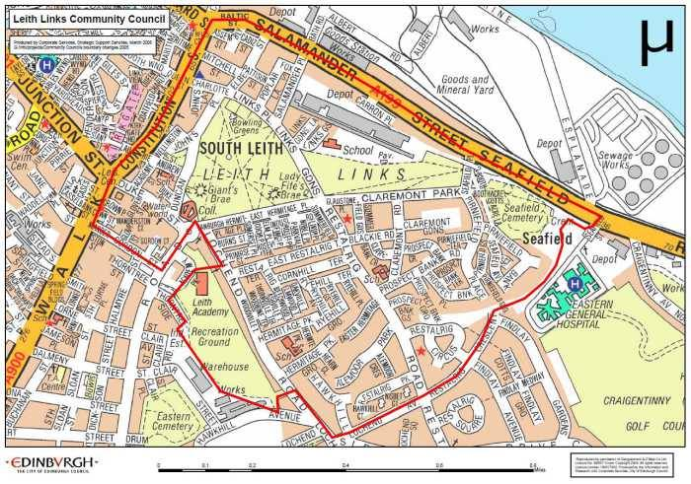 |  | @LeithLinks_CC
 |  | /LeithLinksCC
 |  | www.leithlinkscc.org.uk
 |  | contact@leithlinkscc.org.uk

