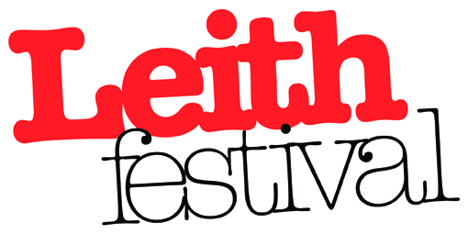
Job Description and Person Specification
Job Title: Leith Festival Coordinator

Payment: £15 per hour
Self Employed Agreement from January to August 2018
Agreed Hours of work
Average 60 hours per month on a flexible basis to meet the needs of the Leith Festival Community Work Plan.
Reporting to and liasing with
Chair of Leith Festival Board

Aims
The purpose of the Leith Festival Coordinator role is to support the Board in achieving its goals for Leith Festival through delivery of its approved 2018 Community based Work Plan
Priorities
Deliver the 2018 Work Plan by coordinating the full range of activities and key events including Burns Night, AGM, Festival Week Programme and Gala Day, in conjunction with Board members where appropriate.
Create processes to monitor and evaluate event outcomes.
Recruit, manage and develop volunteers for all events, in particular for Gala day.
Expand the network of supporters, donors and sponsors and manage those relationships.
Work in partnership with other community led organisations and businesses to support Leith Festival aims.
Improve marketing and promotion of Leith Festival and in particular develop the Leith Festival website including website content management and expand the use of social media.
Assist the board with the identification of funding sources and completion of funding applications.
Take personal responsibility for the completion of all project management, communications, IT and administrative tasks to achive the above priorities.

Leith Festival Coordinator: Person Specification

Experience
Essential | Desirable
- Demonstrate the ability to organise community based events /project management  - Proven track record of fundraising and making funding applications  - Website content management  - Volunteer development | - Experience of project management  - Experience of organising events  - Community Education or Arts Administration Degree

Skills
Essential | Desirable
- Strong organisational skills and the ability to prioritise own workload, personally and within a volunteer context
- Good communications and interpersonal skills in a variety of situations
- The ability to work collaboratively and develop effective networks
- Ability to work autonomously with Information and Communication Technologies (including social media, email, spreadsheets and databases) effectively in a campaigning context
- Abiliy to cost activities and manage budgets

Aptitudes
Essential | Desirable
- Commitment to the ethos and aims of Leith Festival
- Value the importance of an inclusive community based arts organisation
- Self motivated and assertive
- Promote a professional approach in all aspects of the role

