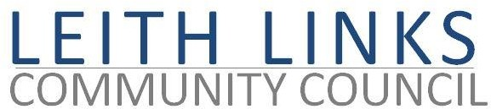AGENDA

MONDAY 29 October 2018
6:30pm
LEITH COMMUNITY CENTRE (NEWKIRKGATE)

- Welcome
Introductions & Apologies

- Police Report & questions (brief)
- Adoption of Minutes of previous meeting (24/09/18)
  - Matters Arising (that are not on Agenda below)
  - Outstanding Actions
  - Notice of new issues members of public intend to raise (now or under 10, below)
6.45 at the latest
- Campervans and Caravans on the Links – Brief Update

- Local Democracy matters
Feedback from EACC
Update from Edinburgh Partnership?
Discussion of possible joint CCs meeting, public meeting (and pre-meeting) - Angus

- Parks and Green Spaces Committee
Leith Links Playpark upgrade – Jac
Toilets Enquiry
Applications for use of Links for Leith Festival Funfair, and Leith Festival Gala Day 2019

- Planning & Licensing Sub Committee – Update – Andrew, Angus, Sally
Transport & Environment (City Mobility, LEZ, Transformation) – Jim, Sally
New local developments –Barratts, Sundial
Licensing – CC voice
Trams – CCTT update
Edinburgh Bus Users Group (EBUG)

- Seafield Sewage – Update
- Participatory Budgeting – Update – Sally
£eith Chooses 2018/2019
Scottish Government Community Choices Support Grant
PB Festival, PB Charter
- Any Other Business - Open Forum Community Centre Management; more

- Date, time, location of next meeting, 26/11/18, 6:30pm, Shore Room, Leith Community Centre
PLEASE NOTE START TIME 6:30

Close of meeting

