EDINBURGH PARTNERSHIP REVIEW AND CONSULTATION OF GOVERNANCE ARRANGEMENTS

Background
The Edinburgh Partnership, as the community planning partnership for the city, has been carrying out a review and consultation of its governance arrangements.
The purpose is to establish a new governance framework, at city, locality and neighbourhood levels, that is:
- simplified with a reduced number of structures than currently;
- provides a shared understanding and increased clarity about what each partnership does;
- provides greater accountability and transparency of decision making; and
- strengthens partnership working and community influence and participation.
A Project Board was established to set out the scope and timescale for the programme of work. This encompassed all community planning arrangements in the city and involved two phases, an initial review followed by a formal consultation which ran from 16 July to 9 September 2018.
The findings from the review and consultation (see Appendix 1), informed the development of proposals for the new arrangements which were initially considered by the Edinburgh Partnership at its meeting on 24 September 2018. This discussion informed the final proposals for the model, which were agreed by the Edinburgh Partnership on 30 October 2018.
The agreed model, set out below, is designed to meet the aims of the review and consultation process, together with the statutory requirements placed on community planning partnerships and public bodies as set out in the Community Empowerment (Scotland) Act 2015.

Governance Model

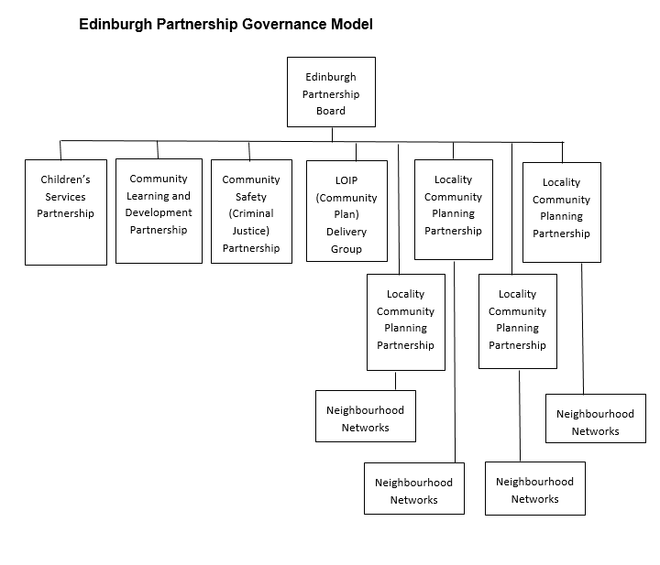
Edinburgh Partnership Board
Under the agreed model, the membership and remit of the Board will be refreshed. The membership will take account of the public bodies which are subject to community planning duties, whilst recognising that there is no requirement that they all must sit on the Board. For the Board to be effective, it will require to:
- comprise senior decision makers, based on a mix of executive and non-executive members;
- recognise those partners that significantly contribute to the delivery of the community plan, locality improvement plans, and other statutory plan requirements;
- consider the role and relationship to the governance arrangements of the individual public bodies;
- achieve a balance between the size of membership, appropriate representation from public bodies and discharging of statutory duties.
The remit will provide a basis for determining the membership. The potential core elements of this are set out below.
- Provide strategic leadership by developing a joint vision and agreed outcomes that improve the quality of life and tackle inequality as set out in the local outcome improvement plan (community plan) and locality improvement plans.
- Put in place administrative structures and operational arrangements which support effective and efficient community planning.
- Ensure the Edinburgh Partnership is accountable to communities.
- Identify, agree and contribute the resources needed to achieve the shared outcomes.
- Hold each other to account for the delivery of outcomes through constructive challenge and effective performance reporting.
- Provide oversight of how the partnership conducts its business.
- Discuss and agree the potential risks the community and partnership is exposed to, including failure to improve outcomes and reduce inequalities and develop a risk management strategy to monitor and manage these risks appropriately.
- Ensure legislative duties are jointly and individually discharged.

Strategic/city level
At this level the model will comprise four partnerships, reduced from the current 11 partnership and advisory groups.
LOIP (Community Plan) Delivery Group
This new group will be accountable to the Edinburgh Partnership Board for leading, delivering and progressing the community plan.
The remit is still to be finalised and potentially covers:
- Planning, overseeing and accountability for the development and delivery of the local outcome improvement plan.
- Advising on, and accountability for, how resources are aligned and allocated to support the delivery of the actions in the local outcome improvement plan.
- Ensuring communities are engaged in the planning and delivery of the Edinburgh Partnership priorities identified in the Community Plan.
- Ensuring the effective management of performance and risk in relation to the delivery of the local outcome improvement plan and report progress to the Edinburgh Partnership Board.
- Maintaining a strong understanding of the emerging needs, circumstances and opportunities relevant to the Edinburgh Partnership priorities, building a robust evidence base of data, information and community intelligence to inform decisions and actions.
- Establishing and maintaining effective relationships with all relevant bodies and partnerships, ensuring appropriate involvement and contribution to the community planning process.
- Putting in place working group arrangements to support the delivery of the role and remit as appropriate, recognising and utilising existing partnership working arrangements to maximise opportunities whilst minimising the additional resource requirements placed on partners.
The group will have flexibility to put in place operational partnership working arrangements to ensure delivery of the community plan. The membership is still to be determined and there is potential through this to ensure linkages between the strategic and locality levels.
Children’s Services, Community Safety and Community Learning and Development Partnerships
These are existing partnerships within the current arrangements. Each has responsibility for the development and delivery of a plan which the Edinburgh Partnership has a level of legal oversight of.
All four partnerships will be directly accountable to the Edinburgh Partnership Board. The specific remits and membership will be subject to further consideration, with this to inform the final governance framework.

Locality/neighbourhood level
The model provides for partnership arrangements at locality and neighbourhood levels.
Locality Community Planning Partnerships
Four new locality community planning partnerships will be created. These will be accountable to the Edinburgh Partnership Board for leading, delivering and progressing the locality improvement plans.
The remit is still to be finalised and potentially covers:
- Planning, overseeing and accountability for the development and delivery of the locality improvement plan.
- Establishing and maintaining effective relationships with all relevant bodies and partnerships, ensuring appropriate involvement and contribution to the locality community planning process.
- Ensuring the effective engagement and participation of all bodies in the development and delivery of locality community planning.
- Ensuring communities are engaged in the identification of priorities, planning and delivery of the locality improvement plan.
- Maintaining a strong understanding of the emerging needs, circumstances and opportunities relevant to the locality, building a robust evidence base of data, information and community intelligence to inform decisions and actions.
- Advising on, and accountability for, how resources are aligned and allocated to support the delivery of the actions in the locality improvement plan
- Ensuring the effective management of performance and risk in relation to the delivery of the locality improvement plan and reporting progress to the Edinburgh Partnership Board.
- Putting in place working group arrangements to support the delivery of the role and remit as appropriate whilst minimising the additional resource requirements placed on partners.
The membership will comprise Edinburgh Partnership members with an appropriate level of delegated responsibility at a locality level to ensure the delivery of the locality improvement plan.
Neighbourhood Networks
The new neighbourhood networks will be based around the existing Neighbourhood Partnership boundaries subject to local consideration and agreement of the Edinburgh Partnership Board.
The role of the neighbourhood networks will be to identify the priorities and outcomes for community planning and to build effective and meaningful community participation. Responsibility for determining how best to ensure the different community voices are heard would form a key element of the networks potential remit.
This will be done by:
- Supporting the identification of outcomes and priorities of the local outcome improvement plan and locality improvement plan, working with partners to develop the appropriate service solutions at a neighbourhood level.
- Supporting the monitoring of progress on the delivery of the Edinburgh Partnership plans, identifying any key issues from a community perspective.
- Supporting and facilitating the participation of all of the community by promoting and developing new methods of engagement. This is particularly to ensure the participation of residents that have not been heard through traditional routes.
- Bringing communities together to promote discussion and dialogue on issues of shared interest and present these views to the Edinburgh Partnership.
- Ensuring no one is treated less favourably and promoting good relations for all.
The above responsibilities are not exhaustive and require further development at a locality and neighbourhood level.
To be effective, the membership of the neighbourhood networks will need to be inclusive and open to all community bodies in the area. It is recognised that whilst a formal ‘representative’ role between the neighbourhood networks and locality community planning partnerships could be adopted, this should not detract from the networks having flexible and tailored operating models.
Whilst there will be flexibility for the neighbourhood networks to develop their membership to reflect their communities, to ensure consistency across the city, a core membership will be identified. This reflects the findings from the review. These members might include:
- Community Councils
- Elected Members
- Faith Groups
- Friends of the Parks Groups
- Parent Councils
- Registered Tenants Organisations
- Residents Associations
- Third Sector Organisations
Neighbourhood Partnerships will continue in their current format as community planning bodies whilst the membership, boundaries and remit of the new neighbourhood networks is considered. This will aim to build on the successes of the Neighbourhood Partnerships while considering areas for improvement taking on board feedback from the review. It is proposed that the new neighbourhood networks will be established in April 2019.
The remit and membership of the locality community planning partnerships and neighbourhood networks will be developed at a local level with all partners as part of a programme of stakeholder engagement. To ensure consistency across the city these will be subject to the agreement of the Edinburgh Partnership Board as part of its governance framework.
Next Steps
In agreeing the governance model, the Edinburgh Partnership Board identified that further work is required. This includes a further programme of engagement with stakeholders involved in the current arrangements, including Neighbourhood Partnerships, during November 2018 to January 2019.
Resourcing for the new arrangements will also need to be agreed, recognising the requirement on public bodies to support the facilitation of community planning.
The Edinburgh Partnership Board has also agreed to develop a communications plan and community participation strategy to support effective partnership working across the city.
It is proposed that the final governance framework and resource assessment will be presented for the agreement of the Edinburgh Partnership Board by March 2019, allowing for the new arrangements to be operational from April 2019.

Contact information
Any further questions please contact communityplanning@edinburgh.gov.uk

