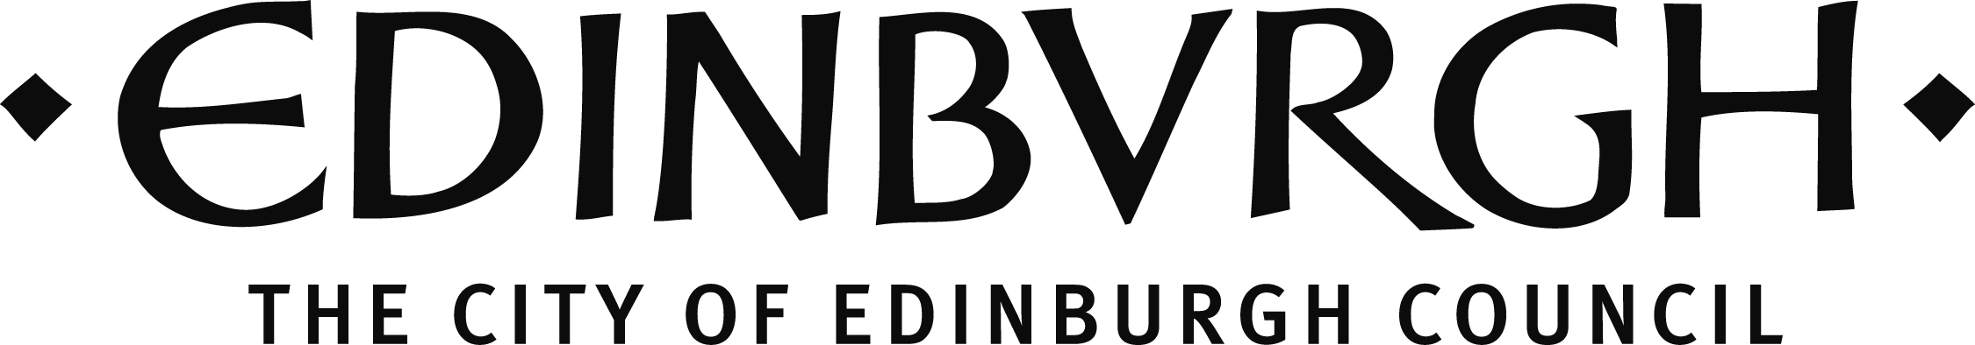

LOCAL EVENTS FUND
APPLICATION FOR FUNDING 2018/19

Privacy statement: Personal information included on this form will only be used by Council staff for purposes of communication with the applicant and facilitating the transfer of funds if the application is successful. Personal information will not be shared with any third party, and will be held for six years from the end of the 2018/19 financial year, before being destroyed.
Further information on how the Council manages your personal information and your rights in relation to this is available on the Council website at www.edinburgh.gov.uk/privacy.
Please read the application guidelines and additional information before completing the form.
Section 1: Organisation Details
Edinburgh Locality | North East
Organisation name
Contact Address

Postcode
Contact Name & Position
Phone
Contact E-mail
Organisation’s website
Please provide an overview of your organisation (max 300 words):

Section 2: Your application

Project Name:
Please provide a description of your project (max 500 words):
Please describe the main beneficiaries of your project and the outcomes you aim to achieve
(max 300words):
Project dates: (Applications will not be considered for projects already started or planned to start, before the panel meeting date):
Start date: |  | Finish date:
Where will your activity take place? (list all locations & include postcodes, where known):
If this is a partnership or consortium application please detail roles and responsibilities of each partner (max 200 words):

Please describe how your proposed project meets the following criteria:
Relevant to priorities in the Local Improvement Plan for the area (max 200 words)
Has a lasting benefit to the Locality (max 200 words)
Includes communities that may have lower levels of access to participation in cultural or artistic activities? (max 200 words)
Demonstrates co-operation and partnership working (max 200 words)

Section 3: Budget

Budget
Details of the budget associated with this project/proposal including a clear statement of partnership funding (either secured, pending confirmation or to be applied for), in-kind contributions and your VAT status. Both income and expenditure should be listed.

Amount requested from Local Events Fund: | £
Expenditure
Breakdown of Estimated Project Costs

item | cost £ | Cash or in-kind
Total Estimated Cost of Project

Income
Sources of income |  | £ | Confirmed  Cash or in-kind
Total Estimated Income for Project
(this figure should equal your expenditure above)
Please attach a copy of your most recent annual (approved/audited) accounts. If your organisation is newly constituted, the most recent bank statement will suffice.
Have you enclosed your accounts/bank statement? | YES/NO

DECLARATION
All applications must be confirmed by two people who are recognised as representatives of your organisation. One of these people must be a board/management committee member.
You are being asked to declare that:
- to the best of your knowledge the information contained in this application, and any accompanying documents, is accurate.
Principal Contact:
Name
Position
Secondary Contact:
Name
Position
e-mail
phone

DEADLINE: 21 December 2018 at 12 noon. We are unable to accept late applications.

Please email an electronic copy of your application to events@edinburgh.gov.uk.

If you do not have access to email, please send a paper copy to:
Culture & Events Office
Cultural Strategy, City of Edinburgh Council
Room 9/47-8
City Chambers, High Street
Edinburgh, EH1 1YJ

