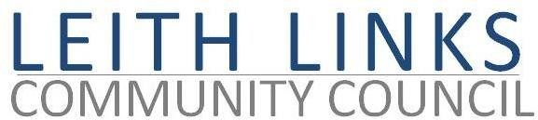
AGENDA

MONDAY 28 October 2019

6:30pm
LEITH COMMUNITY CENTRE (NEW KIRKGATE)

- Chair – Councillor Gordon Munro, Returning Officer for recent CC elections
- Welcome, Apologies, Declaration of Election Results
- Introductions, Declarations of Interest
- Election of Office Bearers (Chair, Vice Chair, Secretary, Treasurer, Engagement Officer)
- AOCB
- Date of next meeting (25th November 2019)
At this stage in the meeting, the newly elected Chair will take over
- Police Report & questions (brief)
- Adoption of Minutes of previous meeting (26/08/19 & 30/09/19, 2019)
- Matters Arising (that are not on Agenda below) & outstanding Actions from previous Minutes
- Matters for the Community Council, sub-committees, special interests / expertise of new members:
- Parks and Green Spaces Committee
- Safety, Cleanliness (rats, dead or alive)
- Update on Vanilla Pod coffee stall, playpark, outdoor gym, John Rattray Statue, Park Life etc.
- Friends of Leith Links – next steps?

- Planning & Licensing Sub Committee
- Current Planning applications in our area and other parts of Leith
- Leith Place making, Leith Creative conference
Other parts of Leith
- Sundial, Baltic Street
- 19/03802/PAN 48-50 Iona Street development
- Save Leith Walk update – community buy-out plans
- 19142 PAN Tower Street, additional Barratts Development
- Licensing – Licensing Forum?
- Transport & Traffic
- Tramworks – update. Easter Rd./Duke St. / Lochend Rd. junction, Constitution Street
- Controlled Parking Zone for Leith
- Local Democracy, Community Engagement
- Feedback from EACC
- Leith Neighbourhood Network , NE Locality Community Planning Partnership

- Seafield Sewage Works

- Any Other Business - Open Forum
£eith Chooses
- Future meetings, last Monday of each month, except December. Topics? Invited speakers?
Next meeting: Monday 25 November 2019, NB 6:30pm, Shore Room, Leith Community Centre

