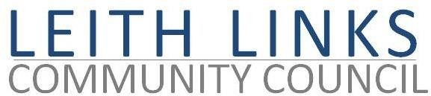
AGENDA

MONDAY 26 October 2020

Via Microsoft Teams

- Adoption of Minutes of previous meeting (28.09.20)
- Reports from Police Scotland, Elected Representatives (CEC, Holyrood, Westminster) as available
- Confirmation of sub-committees and their conveners (Parks & Greenspaces, Planning, Transport & Traffic) and topic leads (Licensing, Seafield, Community Engagement & website).
- To discuss - Aims, Roles and Remits, recruitment of associate members?
- To Note - Public Space Management Plan Consultation – deadline 23 November 2020
- Open Forum / AOCB
- Next meeting: Monday 30th November 2020, 6:30pm via Microsoft Teams

