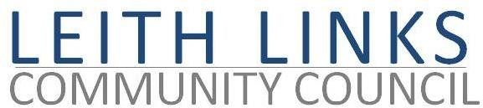
AGENDA

MONDAY 29 March 2021

- Adoption of Minutes of previous meeting (1.3.21)
- Correspondence, Reports from Police Scotland, Elected Representatives (CEC, Holyrood, Westminster) as available
- Parks & Greenspaces matters. Discussion on action re Bowling Green area. Winter Festivals Consultation Q16
- Travel & Mobility matters: Consultations and Responses. Lack of coordination between Trams to Newhaven / Spaces for People / Leith Connections / Low Traffic Neighbourhood / Controlled Parking Zones (CPZ) Phase 1 & 2.
- Seafield Sewage Plant – update
- Planning Matters: Meetings with Developers. Seafield Update
- Open Forum / News & Events in the community / AOCB
- Next meeting: Monday 26 April 2021, 6:30pm

