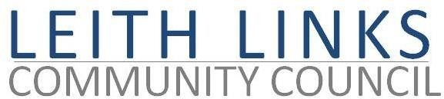
AGENDA

MONDAY 28 June 2021

- Adoption of Minutes of previous meeting (31.5.21)
- Presentation by Miles Wilkinson / & Martyn Lings of City of Edinburgh Council, on the subject of Leith Connections: Cycle route, and Leith Low Traffic Neighbourhood, followed by questions / discussion
- Reports from Elected Representatives (Police Scotland, CEC, Holyrood, Westminster) as available.
- Open Floor and AOCB
- Next meeting: Monday 30 August 2021, 6:30pm

