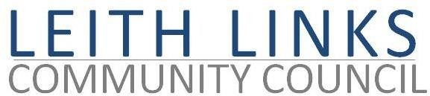
AGENDA

MONDAY 30 August 2021

- Welcome to all, and to new member Robert Cormack of Leith Rotary
- Adoption of Minutes of previous meeting (28.06.21)
- Presentation by Murray McAdam on the subject of Enterprise Car Club, followed by questions / discussion.
- Catch up on events concerning Travel and Mobility (eg. Tram TRO, Phase 1 & 2 Parking Controls, Leith Connections / LTN Consultation report).
- Presentation by Ross Woodside (Edinburgh & Lothians Greenspaces Trust) and colleagues on the consultation concerning the proposed Arboretum on Leith Links, followed by questions / discussion.
- Reports from Elected Representatives (Police Scotland, CEC, Holyrood, Westminster) as available.
- Open Floor and AOCB
- Next meeting: Monday 27 September 2021, 6:30pm

