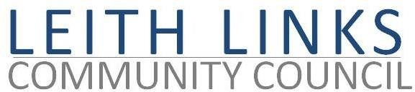
AGENDA

MONDAY 25 October 2021

online

- Welcome to all. New member Barbara Kerr representing Leith Festival.
- Adoption of Minutes of previous meeting (27.09.21) & Matters Arising if not on Agenda below)
- Report from Police Scotland
- Seafield Sewage Works – update and discussion of reporting procedures. Proposal to retain LLCC reporting system (Jim Scanlon, Eileen Simpson)
- Parks and Greenspaces – update on Master Plan for Leith Links, incl. arboretum
- Travel and Mobility Issues – update on Lothian Buses
- Planning issues – (Ropeworks, Maritime Street, Baltic Street)
- Update from Elected Representatives (Holyrood, Westminster, CEC) as available & Open Floor
- AOCB
- Next meeting: Monday 29 November 2021, 6:30pm

