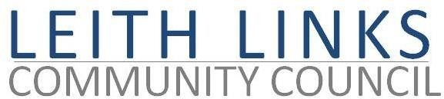
AGENDA

MONDAY 29 November 2021, 6:30 pm

Online Microsoft Teams

- Welcome to all
- Adoption of Minutes of previous meeting (25.10.21) & Matters Arising if not on Agenda below)
- Guest Speaker, Katie Adams from Living Rent Edinburgh / Leith – questions and discussion
- Report from Police Scotland
- Travel and Mobility Issues – CPZ Consultation ends 5 December
- City Plan 2030 – consultation ends 20th December
- Seafield Sewage Work and sewage outflow into WoL – update
- Planning issues - update
- Parks and Greenspaces – update on Master Plan for Leith Links
- Update from Elected Representatives (Holyrood, Westminster, CEC) as available & Open Floor
- AOCB
- Next meeting: Monday 31 January 2022, 6:30pm

