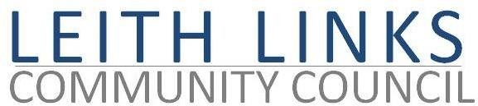
AGENDA

MONDAY 25 April 2022, 6:30pm

Online Microsoft Teams

- Welcome to all, Apologies
- Adoption of Minutes of previous meeting (28.03.22) & Matters Arising if not on Agenda below
- Report from Police Scotland
- Update on Leith Connections / Leith Low Traffic Neighbourhood – Guest Speaker Miles Wilkinson, City of Edinburgh Council
- Lothian Buses – Guest Speaker John White, Lothian Buses
- Licensing – Coffee van on the Links
- Community Activities – Leith Festival Gala Day, Leith Community Big Lunch
- Update on LLCC online Election Hustings 26 April 2022
- Update from Elected Representatives (Holyrood, Westminster, CEC) as available
- Open Floor
- AOCB
- AGM and Next meeting: Monday 30th May 2022, 6:30pm

