AGENDA

AGM
MONDAY 30 May 2022
6:30pm
online, via Microsoft Teams

1. Welcome, Attendance & Apologies
- Minutes of last AGM on 28/06/2021 (Circulated by email and www.leithlinkscc.org.uk)
- Presentation of Annual Report (incorporating Reports from Chair, Secretary & Engagement Officer)
- Treasurer’s Reports & Presentation of Accounts
- Updates, Comments /Remarks, and Adoption of Annual Report(s)
- Election of office bearers (Chair, Secretary, Treasurer, Engagement Officer). Vice- Chair.
- LLCC representation at external groups (Seafield Stakeholder Group, EACC, EBUG, CCTT, £eith Chooses, (Cockburn) Civic Forum)
- Close of AGM

- Next AGM, 2023, date & time tbc

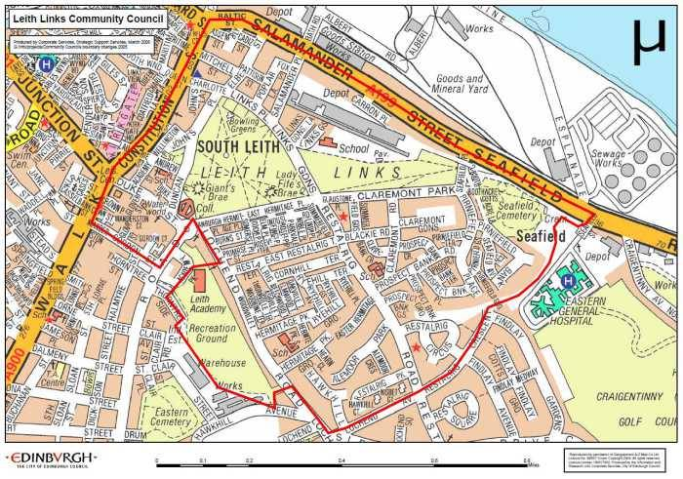 |  | @LeithLinks_CC
 |  | /LeithLinksCC
 |  | www.leithlinkscc.org.uk
 |  | contact@leithlinkscc.org.uk

