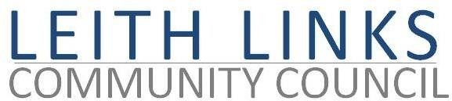
AGENDA

MONDAY 30 May 2022, 7pm

Online Microsoft Teams

- Adoption of Minutes of previous meeting (25.04.22) & Matters Arising if not on Agenda below
- Election / Confirmation of Leaders of internal sub committees – Planning, Licensing, Parks & Greenspaces, Travel & Mobility, Bins and Street Cleanliness
- Update from Elected Representatives as available, and discussion establishing priorities for our area.
- Lothian Buses (lack of) – 22, Leith Links, WGH and safety issues.
- Other Updates – eg. Planning, Licencing
- Community Activities – Gala Day 11th June, Big Lunch 19th June
- Open Floor
- AOCB
- Next meeting: Monday 27 June 2022, 6:30pm

