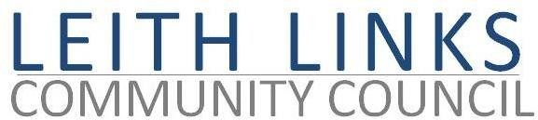
AGENDA

MONDAY 27 June 2022, 6:30 pm

Online Microsoft Teams

- Adoption of Minutes of previous meeting (30.05.22) & Matters Arising if not on Agenda below
- Guest Speakers from Scottish Water and Veolia, to talk about Seafield Sewage Plant. Questions and Discussion
- Guest Speaker 2 from Scottish Historic Buildings Trust, to speak about the plans for the Custom House Leith. Questions and Discussion.
- Live Consultations – Leith Links MasterPlan, Leith Connections, CPZ and ETROs
- Planning – Seafield Master Plan. Harbour 31 - Leith Docks MasterPlan? Halmyre Street site
- Update from Elected Representatives as available
- Open Floor
- AOCB
- Next meeting: Monday 29 August 2022, 6:30pm tbc
NB No CC meeting in July

