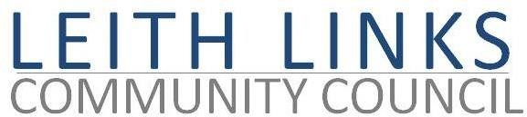
AGENDA

MONDAY 29 August 2022 6:30pm

Online Microsoft Teams

- Welcome, Apologies
- Adoption of Minutes of previous meeting (27.06.22) & Matters Arising if not on Agenda below
- Police Scotland Report
- Travel & Mobility - Guest Speakers from Lothian Buses (to be confirmed) to discuss proposed changes to bus routes in our area. Questions and Discussion
- Bins and Street Cleanliness issues
- Parks & Greenspaces - trees in pots
- Planning – Leith Waterfront, Harbour 31
- Update from Elected Representatives as available
- Open Floor - Input from local Residents
10. AOCB
Vacancies on CC & for group leads
Feedback from: Gala Day; Mela
£eith Chooses
EACC – role for local CCS in cost of living crisis?
Live Consultations – https://consultationhub.edinburgh.gov.uk/ Short Term Lets 2022 – Consultation 2; Womens Safety in Public Places; Ending Poverty Related Hunger in Edinburgh; Community Payback Consultation 2022

- Next meeting: Monday 26 September 2022, 6:30pm

