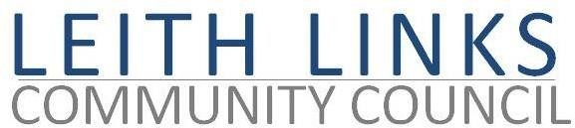

**AGENDA**

# Monday 31 October 2022 6:30pm

# Online Microsoft Teams

1. Welcome, Apologies
2. Adoption of Minutes of previous meeting (26.09.22) & Matters Arising if not on Agenda below
3. Police Scotland Report
4. Travel & Mobility - **Guest Speaker from CEC to talk about Leith Controlled Parking Zone and how it will affect our area – SPEAKER STILL**  **TO BE CONFIRMED**  
   Street Lighting issues, Local Bus Routes
5. Bins and Street Cleanliness issues
6. Parks & Greenspaces
7. Planning Issues
8. Seafield Sewage
9. Update from Elected Representatives as available
10. Open Floor - Input from local Residents
11. AOCB
12. Next meeting: **Monday 28 November 2022, 6:30pm**