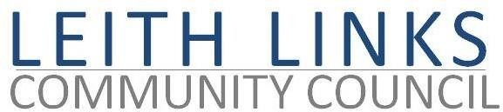
AGENDA

Monday 27 February 2023 6:30pm

In-person at Duncan Place community hub

- Welcome, Apologies
- Adoption of Minutes of previous meeting (30.01.23) & Matters Arising if not on Agenda below
- Guest Speaker: Jim Jarvie from Friends of the Water of Leith Basin (FOWL.b)
- Police Scotland Report if available.
- Update from Elected Representatives as available.
- Open Floor - Input from local Residents
- Transport & Mobility
- Parks & Greenspaces
- Planning Issues
- Seafield Sewage
- AOCB

- Next meeting: Monday 27 March 2023, 6:30pm

