AGENDA

AGM
MONDAY 29 May 2023
6:30pm
In-person, at Duncan Place

1. Welcome, Attendance & Apologies
- Minutes of last AGM on 30/05/2022 (Circulated by email and at www.leithlinkscc.org.uk)
- Presentation of Annual Report (incorporating Reports from Chair & Secretary)
- Treasurer’s Reports & Presentation of Accounts
- Updates, Comments /Remarks, and Adoption of Annual Report(s)
- Election of office bearers (Chair, Secretary, Treasurer, Engagement Officer). Vice- Chair.
- LLCC representation at external groups (Seafield Stakeholder Group, EACC, EBUG, CCTT, £eith Chooses, (Cockburn) Civic Forum, Leith Links MasterPlan Working Group.
- Close of AGM

- Next AGM, 2024 date & time tbc

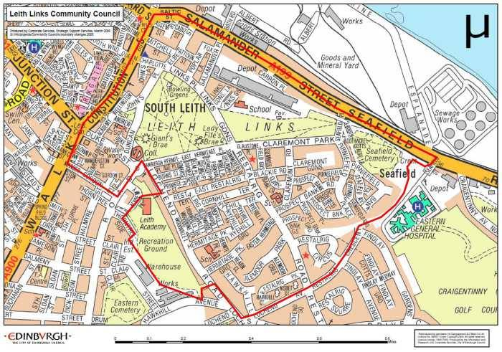 |  | @LeithLinks_CC
 |  | /LeithLinksCC
 |  | www.leithlinkscc.org.uk
 |  | contact@leithlinkscc.org.uk

