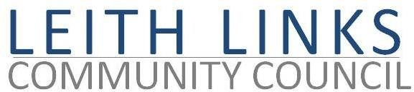
AGENDA

Monday 29 May 2023 6:30pm

In person, at Duncan Place

- Welcome
- Adoption of Minutes of previous meeting (24.04.23)
- Police Scotland Report if available

- Elections of leads on community council sub-committees

- Update from Elected Representatives as available

- Open Floor –Issues raised by Local Residents

- Transport, Travel & Mobility – Roll out of the CPZ, the Leith Connections & Low Traffic Neighbourhood. Can we monitor the effects of this ourselves, to complement data from Council? Journey diaries? Street diaries?
- Leith Links Events - Leith Festival Gala Day plans; Proclaimers Concert plans

- AOCB

- Next meeting: Monday 26 June 2023, 6:30pm

