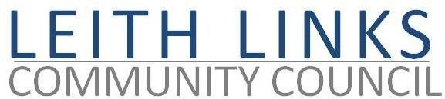

AGENDA

Monday 27 October 2025, 6:30pm

Duncan Place

- Welcome & Apologies
- Adoption of Minutes of previous meeting (2.09.25) & Matters Arising
- Police Report if available
- Visiting Speaker - Gareth Barwell, Interim Corporate Director of Place, CEC + Q&A / discussion
- Update from City Councillors
- Issues raised by Local Residents
- Seafield – feedback and next steps
- Planning
- AOCB (including updates on Licensing, Trave & Mobility, Parks & Greenspaces
- Next Meeting – Monday 24 November 2025, in-person at Duncan Place (tbc)

