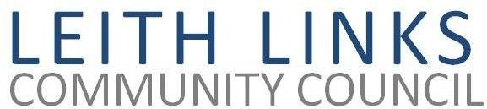

AGENDA

Monday 23 February 2026, 6:30pm

Duncan Place

- Welcome & Apologies.
- Adoption of Minutes of previous meeting (26.01.2026) & Matters Arising
- Police Report if available
- Guest Speaker: Matt Farnham, Community Engagement and Operational Communications Coordinator, Veolia, to give us an update re Seafield sewage plant.
- Update from City Councillors
- Issues raised by Local Residents
- Guest Speaker: Rachel Hutton, Harbour Homes, to talk about the Leith Network
- Parks & Greenspaces – update, Thriving Green Spaces, toilets, Friends group, Visitor Levy funds
- Draft Leith Place Plan – comments and decisions…
- Transport & Mobility – update, CPZ, Leith Connections
- Planning - update
- AOCB - events in parks
- Next Meeting – Monday 30 March 2026, in-person at Duncan Place

