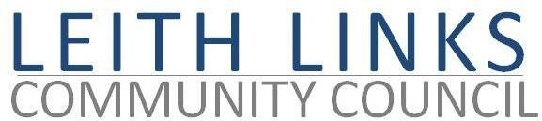

AGENDA

Monday 30 March 2026, 6:30pm

Duncan Place

- Welcome & Apologies.
- Adoption of Minutes of previous meeting (23.02.2026) & Matters Arising
Rolling Action List:
- Aric Gilinsky will look into sorting out Complaints form on website
- Angus Hardie will try to get resources to help with website, from SW or Veolia
- Chas Booth will contact Council Officers for update of CPZ plans for next Phase
- Secy will book stall at Leith Festival Gala Day and ask other 2 Leith CCs to share
- Abigail, Barbara, Sally, Teresa will liaise with Place Plan authors

- Police Report if available
- If available, Matt Farnham, Community Engagement and Operational Communication Coordinator, Veolia, update re Seafield sewage plant.

- Update from City Councillors
- Issues raised by Local Residents
- Draft Leith Place Plan – comments and decisions…
- Parks & Greenspaces – Events, update from Thriving Green Spaces, toilets, mural, Friends group,
- Planning – update, Salamander Place / Street
- Transport & Mobility – update, Leith Connections, local needs, CPZ
- AOCB - LLCC AGM, Hustings, Gala Day ideas
- Next Meeting – Monday 27 April 2026, in-person at Duncan Place

