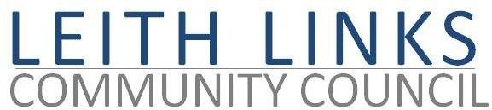

AGENDA

Monday 27 April 2026, 6:30pm

Duncan Place

- Welcome & Apologies.
- Adoption of Minutes of previous meeting (30.03.2026) & Matters Arising

- Police Report if available
- Guest Speakers: Sutherland Forsyth & Sam Gallacher of Scottish Historic Buildings Trust, on Leith Museum at Custom House

- If available, Matt Farnham, Community Engagement and Operational Communication Coordinator, Veolia, update re Seafield sewage plant.

- Update from City Councillors
- Issues raised by Local Residents
- Parks & Greenspaces – Update from Thriving Green Spaces, playpark, toilets, mural, Friends Group.
- Draft Leith Place Plan – update
- Planning – update
- Transport & Mobility – update, local resilience, Leith Connections
- AOCB - AGM prep, recruiting new members, Gala Day ideas
- Next Meeting and AGM – Monday 25 May 2026, in-person at Duncan Place

