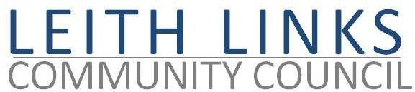

AGENDA

Monday 25 May 2026, 6:30pm

Duncan Place

- AGM - Welcome & Apologies. – Chair Councillor Chas Booth
- Adoption of Minutes of previous AGM (28 April 2025)

- Presentation of Annual Report 2025-2026 - Abigail Cunningham / Sally Millar
- Presentation of Annual Accounts 2025-2026 – Aric Gilinsky
- Election of Office Bearers
- Close AGM

Short break

Ordinary CC Meeting - Chair Abigail Cunningham
- Adoption of Minutes of previous meeting (37.04.2026) & Matters Arising

- Police Report if available
- Guest Speakers: Jo Hirst and Doreen Goldie speaking on The Campaign to Stop Spreading Sewage Sludge-cake

- Update from City Councillors
- Issues raised by Local Residents
- Parks & Greenspaces – Update, Thriving Green Spaces, playpark, toilets, mural, Friends Group
- Draft Leith Place Plan – update
- Planning – update
- Transport & Mobility – update
- AOCB - Gala Day ideas
- Next Meeting and AGM – Monday 29 June 2026, in-person at Duncan Place

